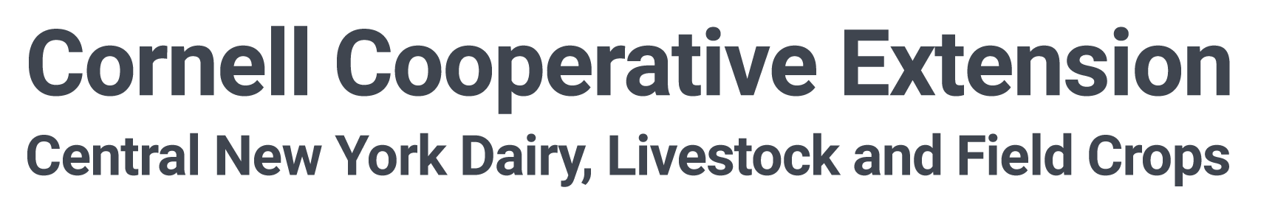

FOR IMMEDIATE RELEASE
Contact: Nicole Tommell
CNY Dairy, Livestock, and Field Crops Program
Cornell University Cooperative Extension
315-867-6001
nt375@cornell.edu

Katelyn Walley
SWNY Dairy, Livestock, and Field Crops Program
Cornell University Cooperative Extension
716-640-0522
kaw249@cornell.edu

Cash Rents and Custom Harvest Rates Survey – Responses Needed
Cornell Cooperative Extension Collects Survey Data to Help NY Farmers
by Katelyn Walley, Farm Business Management Specialist with the SWNY Dairy, Livestock, and Field Crops Program

SOUTHWEST, NEW YORK (April 1st, 2024) – Having solid data and helpful resources is important for any business owner – but this information is critical for farmers looking to diversify and adjust to meet the unique challenges that face the agricultural industry. Regionally specific, and up-to-date, information is necessary to make informed decisions.

A team of Cornell Cooperative Extension Farm Business Management Specialists are working to fill in some missing information gaps with a new project – the 2024 Cash Rents and Custom Harvest Survey, funded by New York Farm Viability. This is survey, and accompanying resources, is available by visiting https://farmbusiness.cornell.edu/cashrates/.

The survey collects information on average rental rates for facilities and land, as well as ranges of custom service fees for things like hay harvesting activities, equipment use, and custom labor. All this information is collected anonymously and will be compiled to provide regional averages for areas across New York State. This will create a better understanding and starting point for farm owners to improve their negotiations and farm sustainability.

Project Leader, Katelyn Walley, is the Farm Business Management Specialist with Cornell Cooperative Extension’s Southwest New York Dairy, Livestock, and Field Crops Program. For her, this information will provide a helpful starting point for farms looking to make informed decisions. “I’m working with a lot of farms right now who are struggling to make ends meet. Sometimes,” says Walley, “the conversation gets to a point where we’re looking at ways to save money, be more efficient, or possibly change what we’re producing or managing”. Walley states that, “The data from this survey will help farms decide what works best for them and what their options might be to continue forward”.

Nicole Tommell, Project Co-Leader, is the Farm Business Management Specialist with Cornell Cooperative Extension’s Central New York Dairy, Livestock, and Field Crops Program. She states that, “Landowners and farmers often reach out to CCE Specialists across the state to understand what a fair price might be for land rental and custom cropping services”. She continues, “For years, the answer has been to check information from other states’ websites and make educated guesses. Our project will help provide a more helpful, and specific, answer”.

Farm owners, land owners, and agribusiness specialists are encouraged to fill out the anonymous survey by visiting: https://farmbusiness.cornell.edu/cashrates/. For folks who need a paper copy, call Katelyn (716-640-0522) or Nicole (315-867-6001) to have one mailed for your convenience.

This project is funded through a grant from New York Farm Viability Institute: https://nyfvi.org/.
SWNYDLFC is a partnership between Cornell University and the CCE Associations of Allegany, Cattaraugus, Chautauqua, Erie, and Steuben counties. Their team includes Katelyn Walley, Farm Business Management and Team Leader (716-640-0522); Camila Lage, Dairy Management (607-422-6788); Katelyn Miller, Field Crops (716-640-2047) and Amy Barkley, Livestock Management (716-640-0844). CCE is an employer and educator recognized for valuing AA/EEO, Protected Veterans, and Individuals with Disabilities and provides equal program and employment opportunities.
###

For more information about Cornell Cooperative Extension, contact your county’s Association Executive Director. Allegany County – Laura Hunsberger, lkh47@cornell.edu or 585-268-7644. Cattaraugus County – Kelly McDonald, kmm525@cornell.edu or 716-699-2377. Chautauqua County – Emily Reynolds, eck47@cornell.edu or 716-664-9502. Erie County – Diane Held, dbh24@cornell.edu or 716-652-5400. Steuben County – Tess McKinley, tsm223@cornell.edu, or 607-664-2301.

